Using a different repo instead:

git clone <https://github.com/kennonsr/hadoop_hbase_hive_spark_docker.git>

(Both hbase and beeline connected)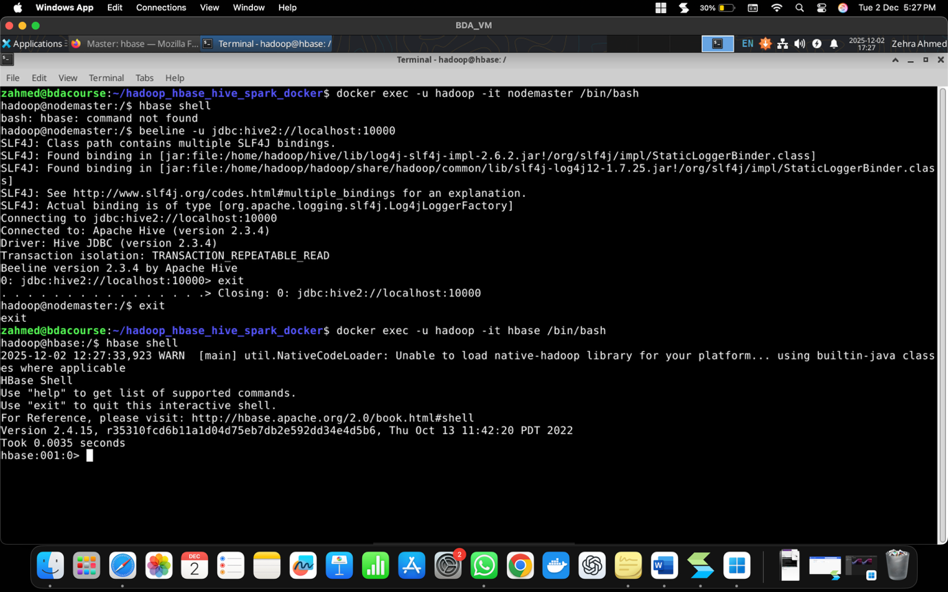

Now starting the lab again from scratch.

[ToDo: Paste relevant snapshot at port 16010]

http://localhost:16010/master-status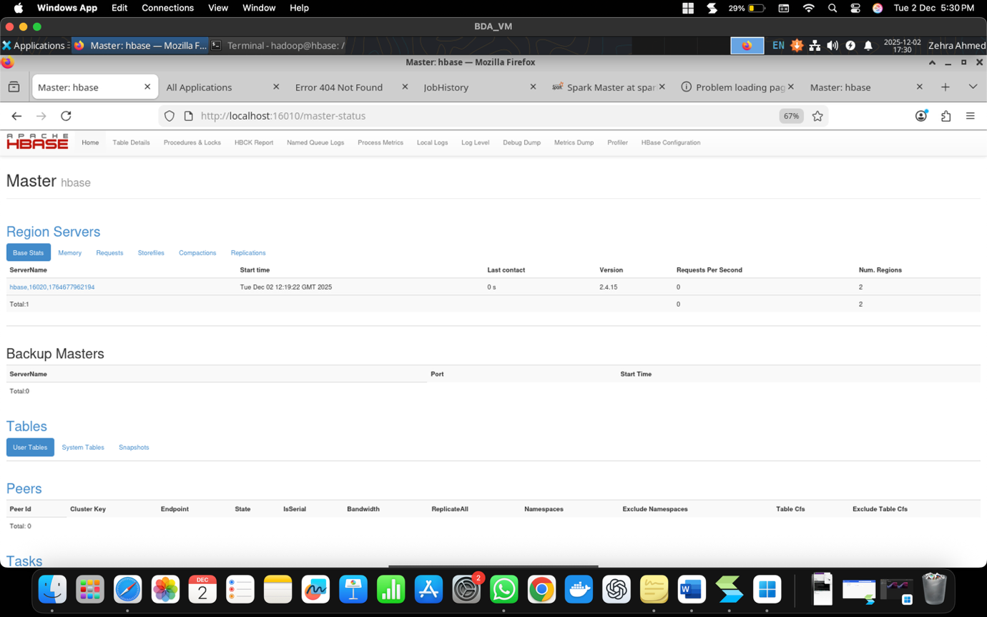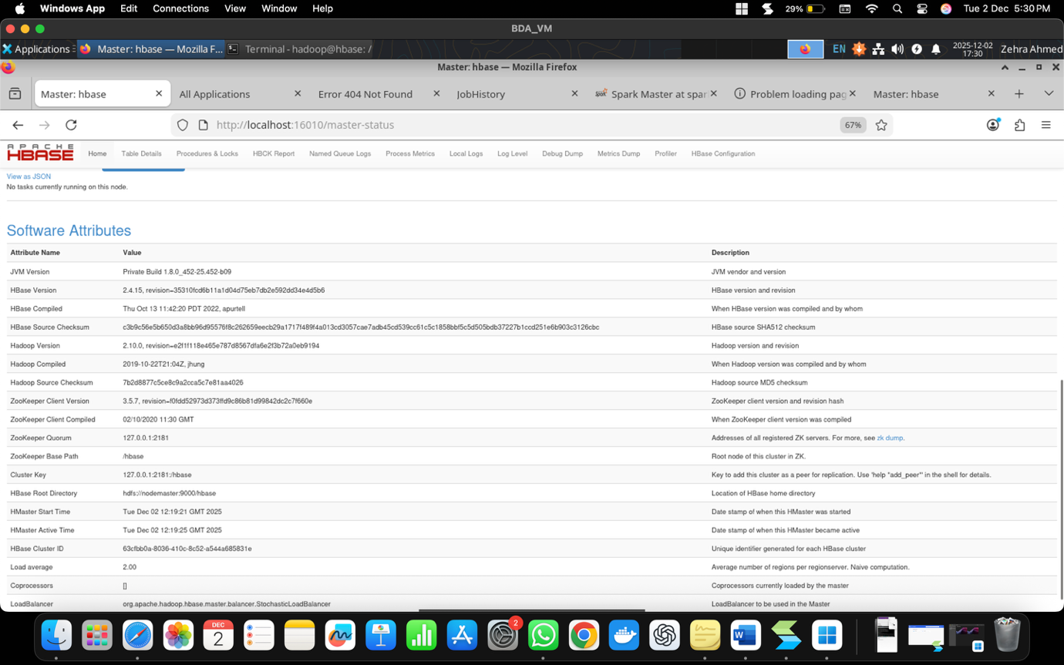

[http://172.20.1.1:8088/cluster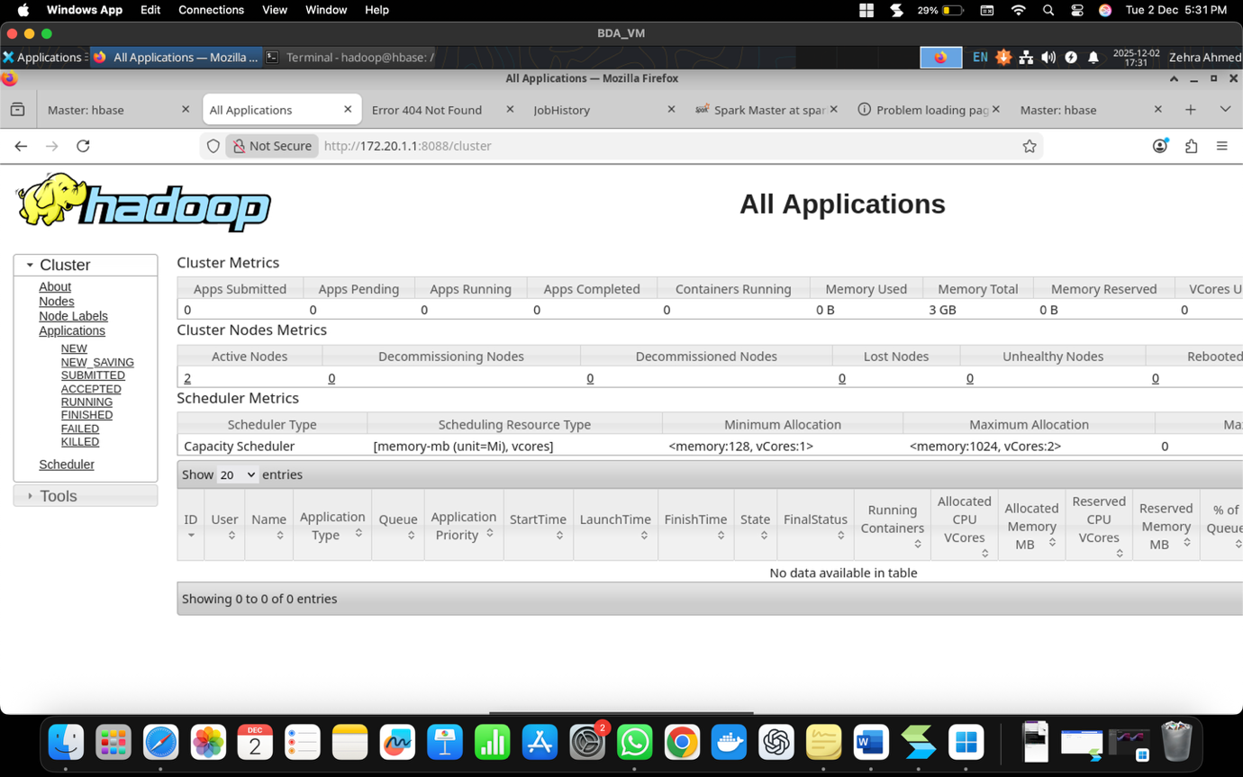](http://172.20.1.1:8088/cluster)

[http://172.20.1.1:19888/jobhistory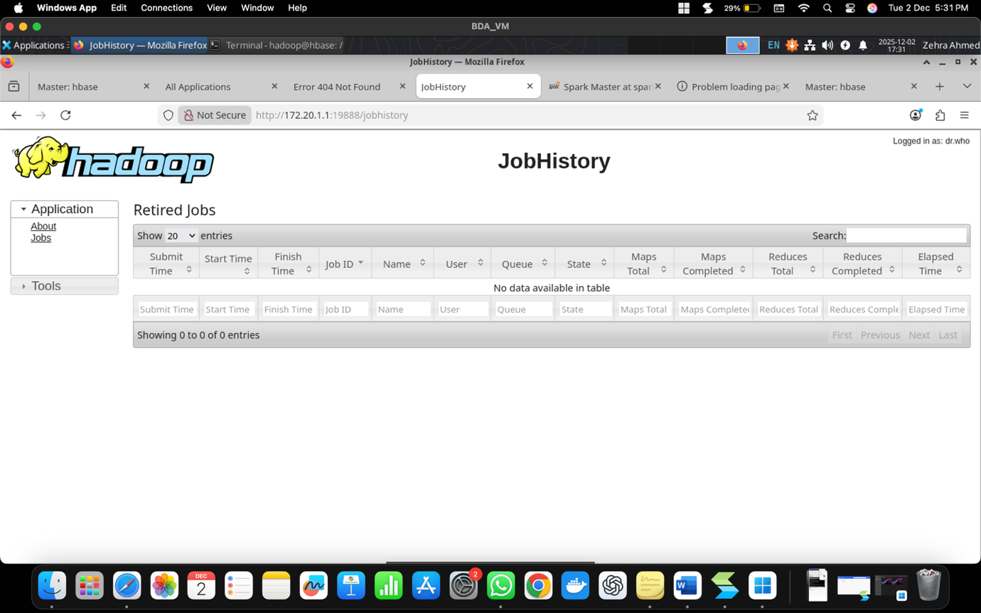](http://172.20.1.1:19888/jobhistory)

[http://172.20.1.1:8080/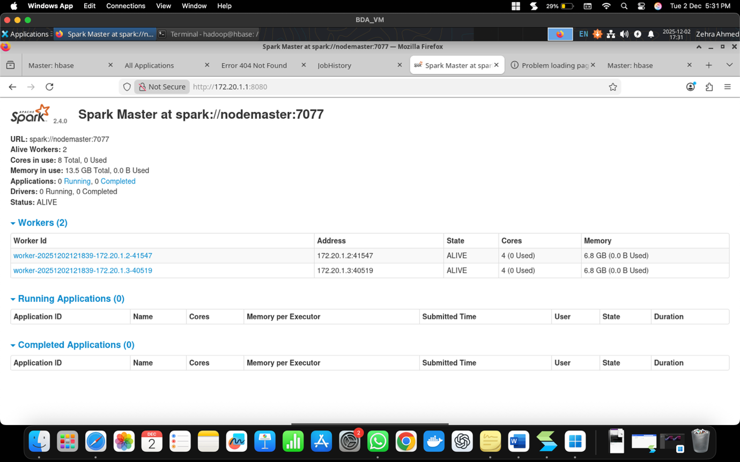](http://172.20.1.1:8080/)

The screenshot below shows the following commands executed:  
docker exec -u hadoop -it hbase /bin/bash

hbase shell

list

status

version

table_help

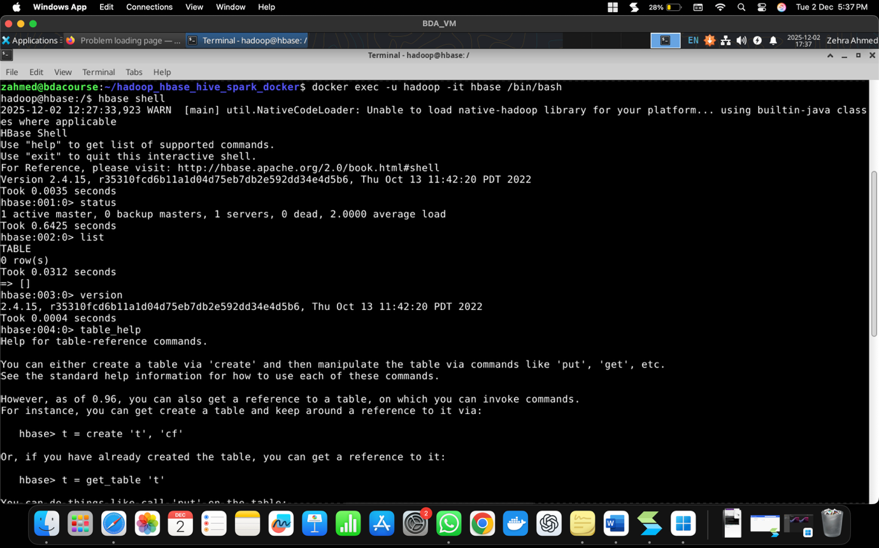

Created ecommerce_transactions table. Inserted rows using Put. Tried Get. 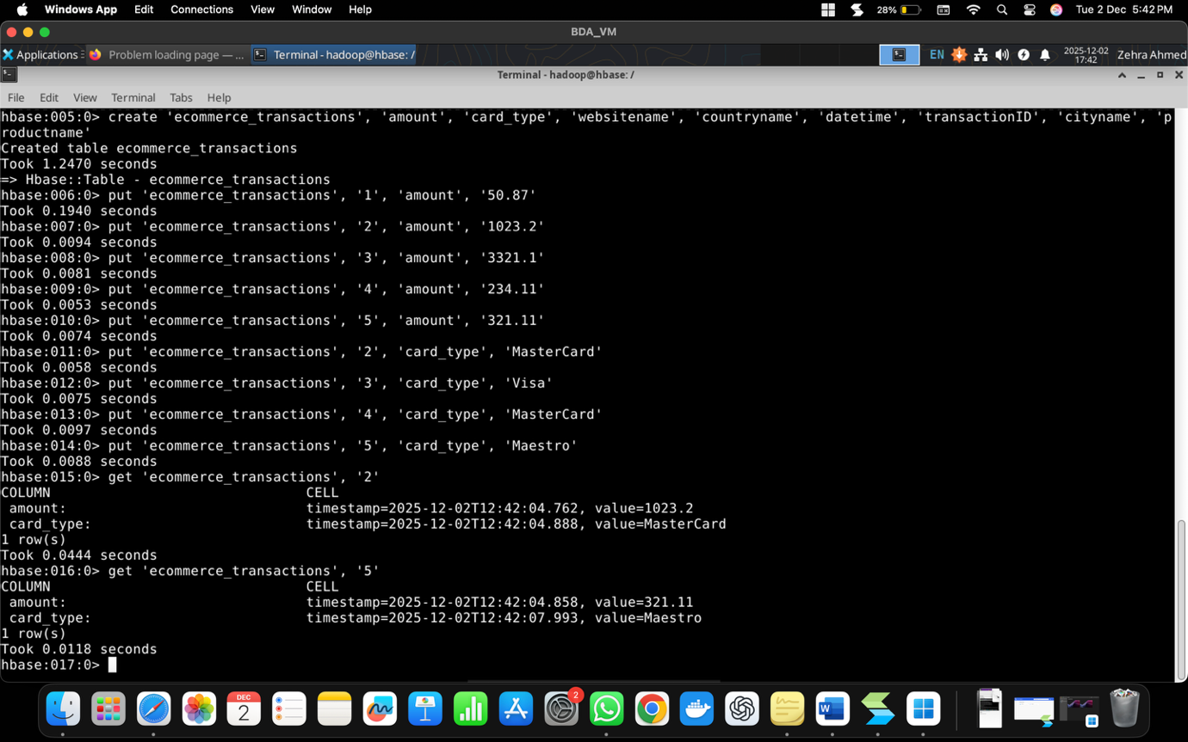

Got Description. 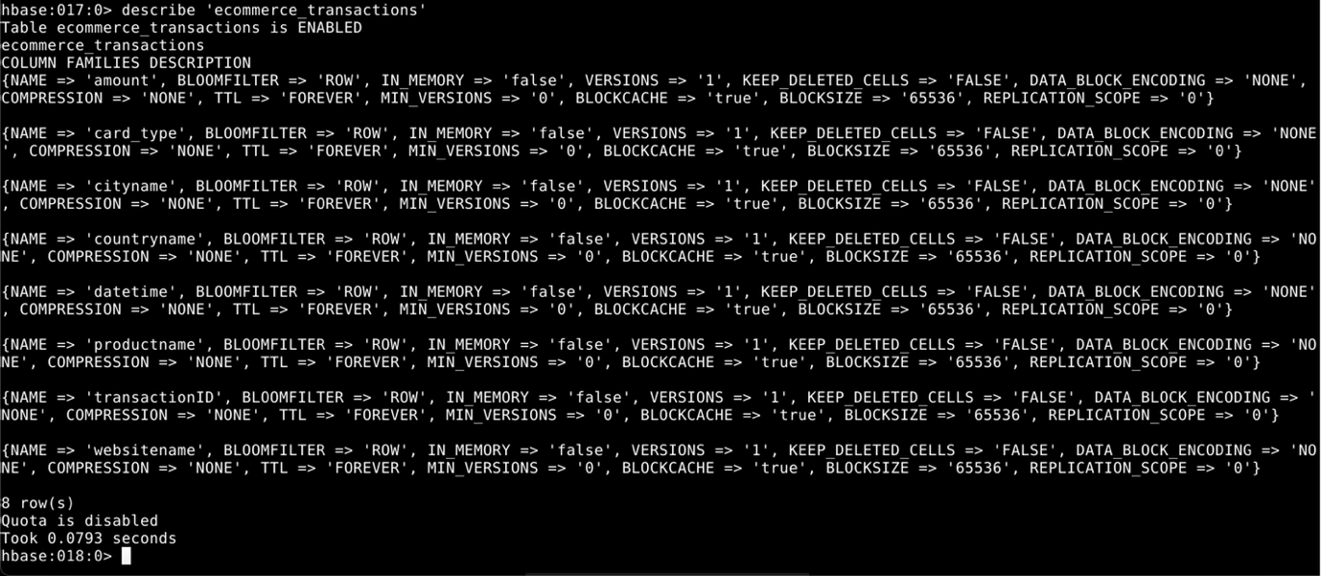

Altered table, deleted cell and then row in table. Count rows. Disabled, dropped and recreated the table. Tried exists, scan, disable and drop.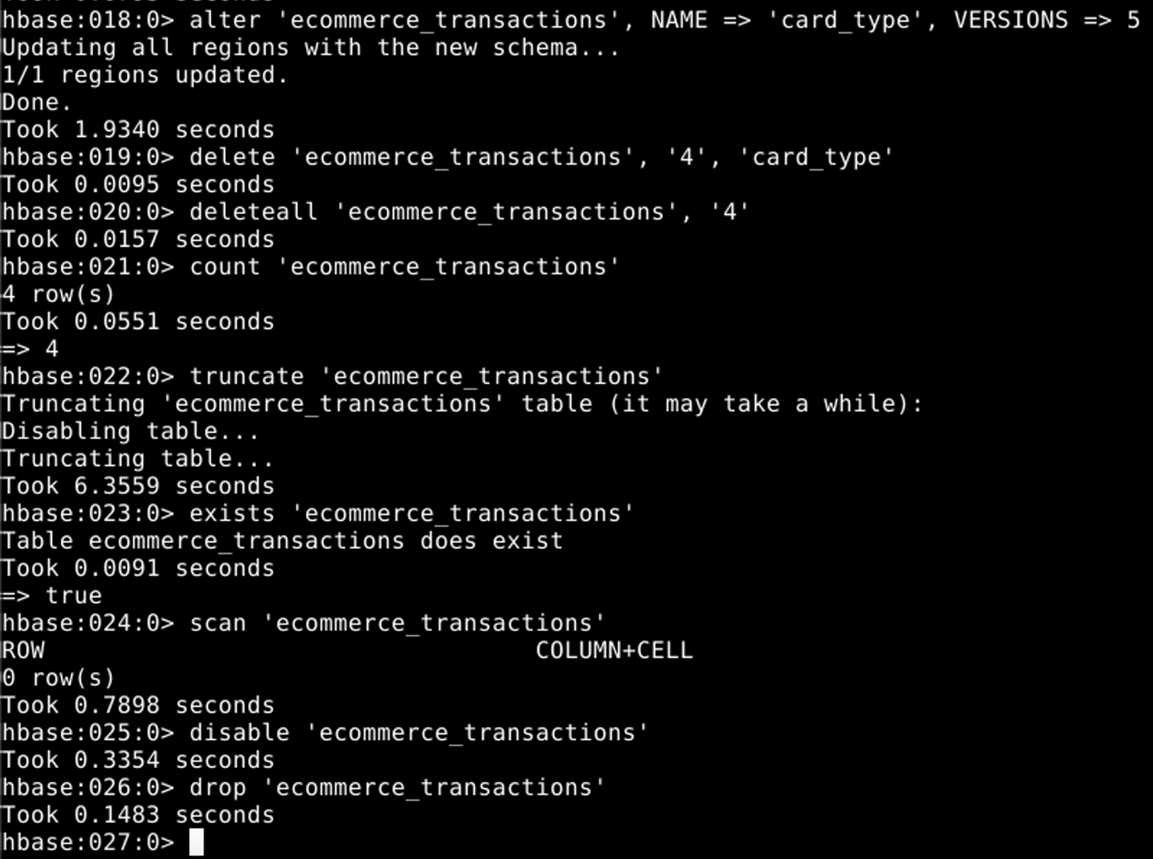

Recreating the table for next steps:

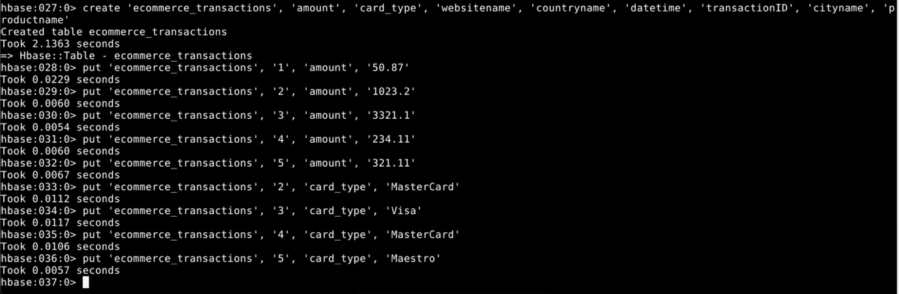

Scan Filter Exercises.

[ToDo: Paste snapshot of 2 filter outputs]

show_filters

KeyOnlyFilter: scan 'ecommerce_transactions', {FILTER => "KeyOnlyFilter()"}

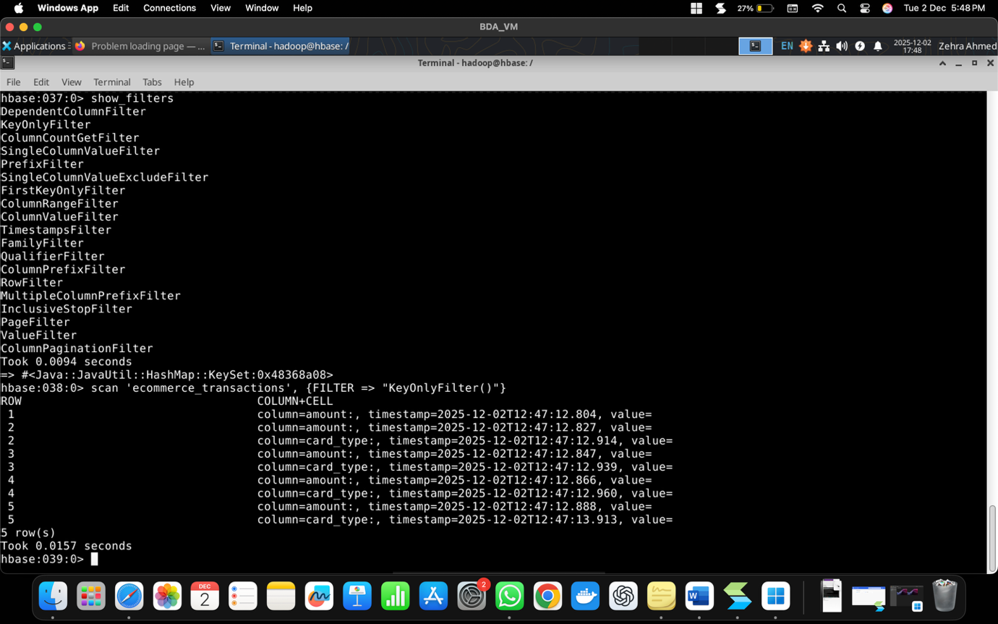

PrefixFilter: scan 'ecommerce_transactions', {FILTER => "PrefixFilter('1')"}

Combined: scan 'ecommerce_transactions', {FILTER => "PrefixFilter('2') AND KeyOnlyFilter()"}

ColumnPrefixFilter: scan 'ecommerce_transactions', {FILTER => "ColumnPrefixFilter('c')"}

MultipleColumnPrefixFilter: scan 'ecommerce_transactions', {FILTER => "MultipleColumnPrefixFilter('c','p')"}

PageFilter: scan 'ecommerce_transactions', {FILTER => "PageFilter(2)"}

(because we inserted data using **put 'table','row','family','value'** instead o**f put 'table','row','family:qualifier','value'**, the qualifier names in the table are all “” and so the last 2 filter outputs above had nothing being returned.)

Combined Page + ColumnPrefix: scan 'ecommerce_transactions', {FILTER => "PageFilter(3) AND ColumnPrefixFilter('c')"}

InclusiveStopFilter: scan 'ecommerce_transactions', {FILTER => "InclusiveStopFilter('4')"}

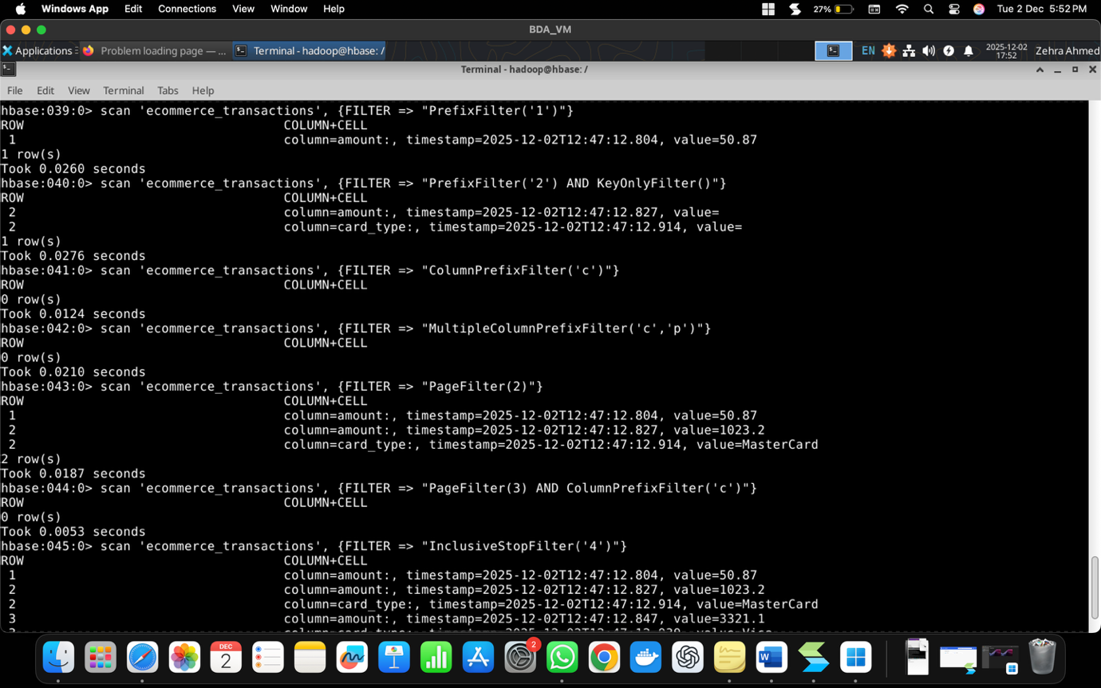

For the next two filters “'binary prefix:M'” is outdated and these are the correct codes instead:  
ValueFilter: scan 'ecommerce_transactions', {COLUMNS => 'card_type', FILTER => "ValueFilter(=, 'regexstring:^M')"}  
ValueFilter for countries > 'I': scan 'ecommerce_transactions', {COLUMNS => 'countryname', FILTER => "ValueFilter(>, 'binary:I')"}  
STARTROW: scan 'ecommerce_transactions', {STARTROW => '3'}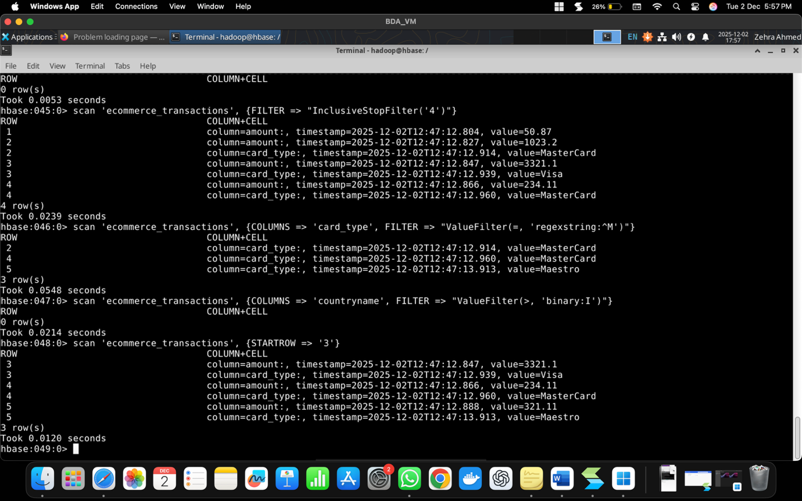

Integrating Hive and Hbase:

Already in hbase shell. Creating transaction_detail_Hbase_tbl and inserting the data row by row for all 5. [ToDo: Paste Snapshot of below]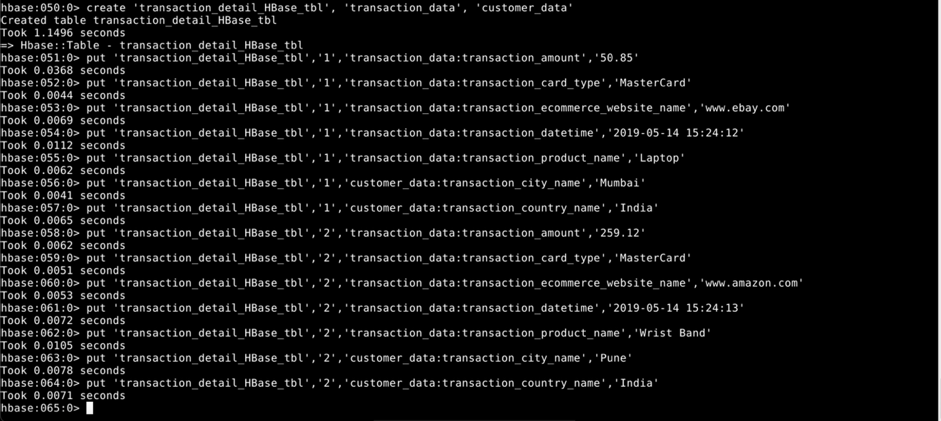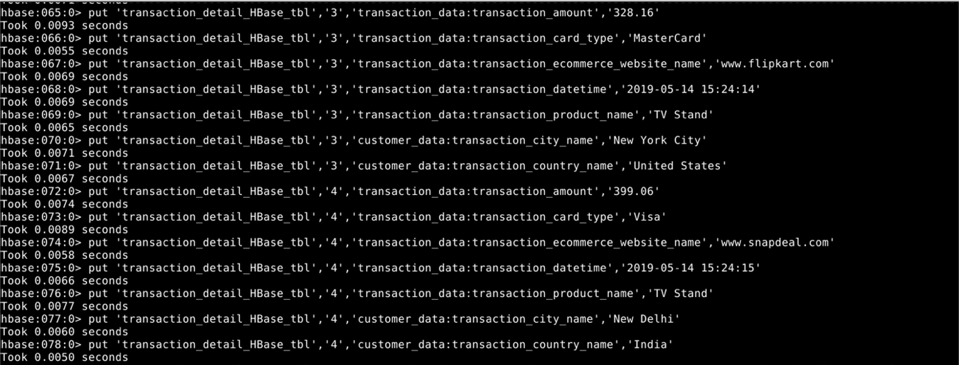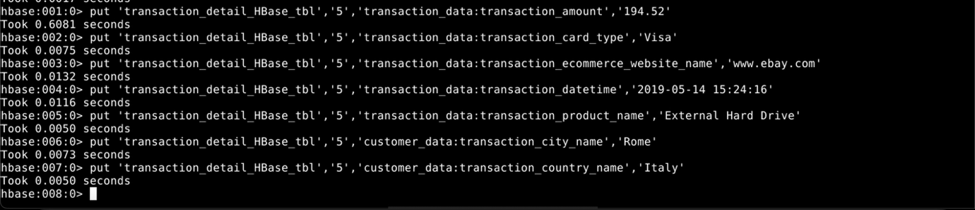

Verifying using scan 'transaction_detail_HBase_tbl'. [ToDo: Paste Snapshot of below]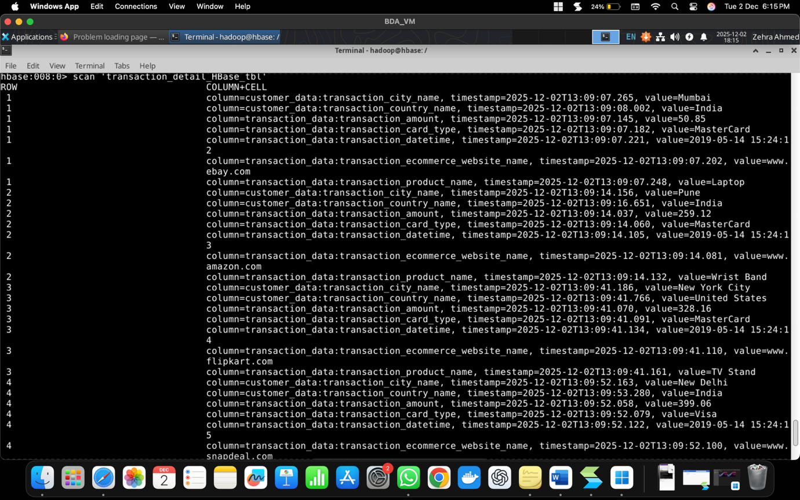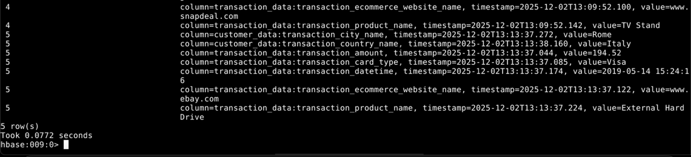

Exiting hbase and enterring beeline using

docker exec -u hadoop -it nodemaster /bin/bash

beeline -u "jdbc:hive2://nodemaster:10000/"

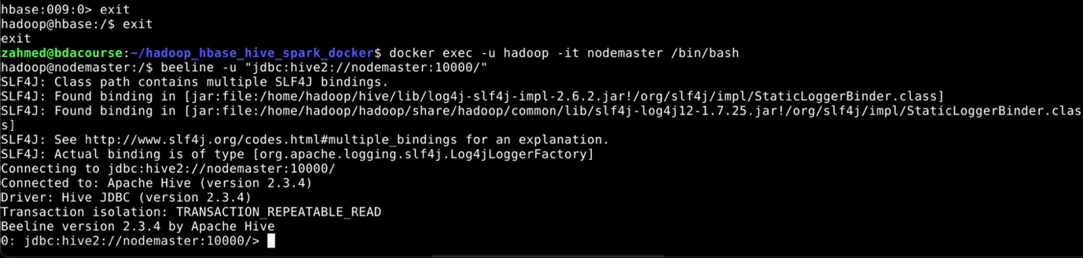

Inside Hive shell:

show databases; create database mydb300;

use mydb300;

CREATE EXTERNAL TABLE transaction_detail_hive_tbl(transaction_id int, transaction_card_type string, transaction_ecommerce_website_name string, transaction_product_name string, transaction_datetime string, transaction_amount double, transaction_city_name string, transaction_country_name string) STORED BY 'org.apache.hadoop.hive.hbase.HBaseStorageHandler' WITH SERDEPROPERTIES ("hbase.columns.mapping" = ":key,transaction_data:transaction_card_type,transaction_data:transaction_ecommerce_website_name,transaction_data:transaction_product_name,transaction_data:transaction_datetime,transaction_data:transaction_amount,customer_data:transaction_city_name,customer_data:transaction_country_name") TBLPROPERTIES ("hbase.table.name" = "transaction_detail_HBase_tbl"); [ToDo: Paste Snapshot of below]

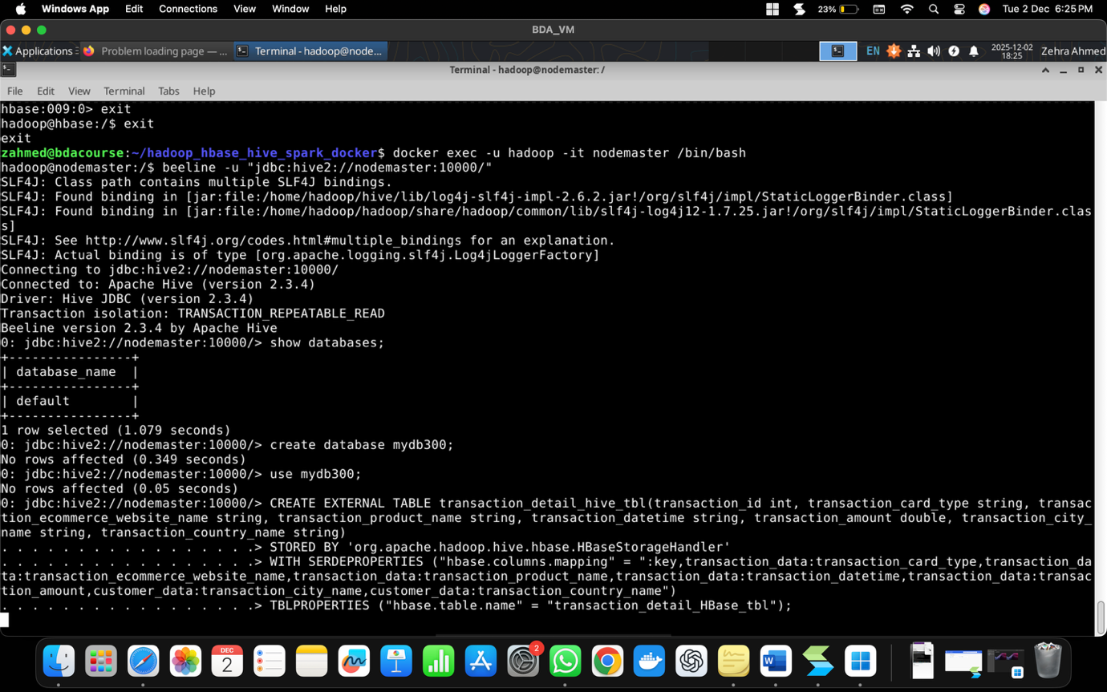

This resulted in an error:

The error "org.apache.hadoop.hbase.client.RetriesExhaustedException: Can't get the locations" occurs because Hive cannot connect to HBase to verify the table's existence during the pre-create check in HBaseStorageHandler. This is typically due to missing or incorrect configurations in Hive for accessing HBase, such as the Zookeeper quorum (used for service discovery). Your setup has HBase running in a separate container, so Hive (in nodemaster) needs explicit pointers to HBase's Zookeeper. Wrote a shell script to copy all files (copy.sh). Also transfered all HBase configs (including Zookeeper) to Hive. Updated hive site.xml and restarted cluster.

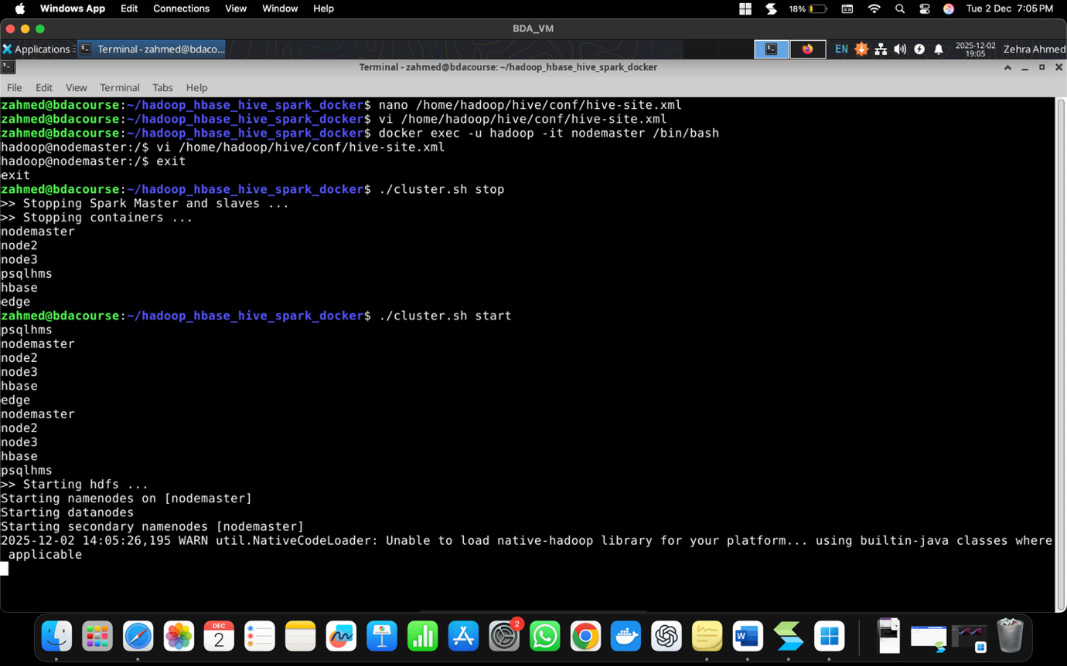

Made sure that things are still integarted:  
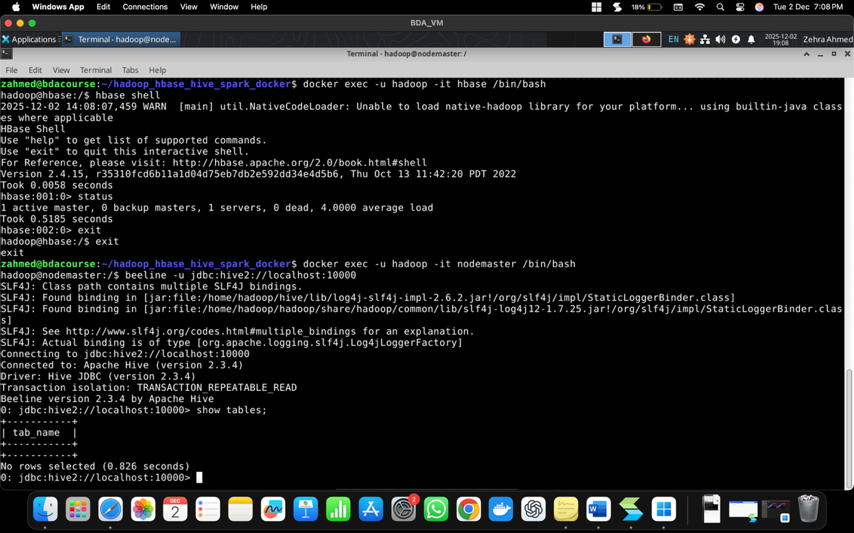

This Worked!

Snippet from Create External Table: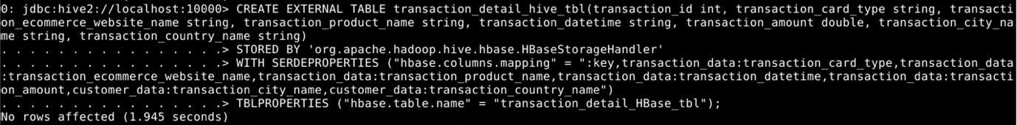

Select * from transaction_detail_hive_tbl [ToDo: Paste Snapshot of below]